
TC-P311MK Spec:F
Four-door network access control
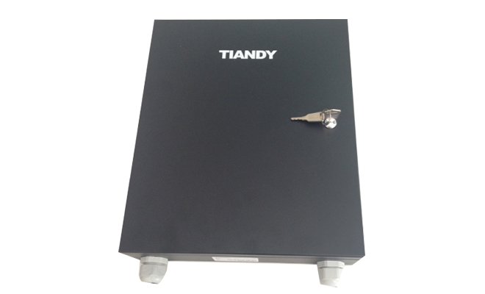

KEY FEATURES

- Supports access control, multi-door interlock, APB control, and first card door opening. The controller is connected to the system over the network. Card table delivery and log uploading are faster and more stable
- 4 bidirectional swipe card control, 5 alarm input, 4 alarm output
- It can store 20,000 card information, 100,000 offline log storage
- It supports 32 schedules, 32 time zone tables, and 60 holiday Settings to meet the needs of different groups at different times
- Supports 1024 working groups, and achieves a variety of open door permissions according to schedule and door control methods
- Supports a variety of door opening methods:
- 1) Multiple cards open the door, a maximum of 20 legitimate cards can be swiped within the specified time to open the door (swipe cards in no order);
- 2) The first card opens the door, you can add 20 cards to the first card, every day after the first card opens the door, other cards have the right to open the door;
- 3) countdown to closing, you can set 20 cards as countdown cards, swipe the card to open the door, after the specified opening time, the door will be closed.
- Remote door opening, countdown door opening and automatic door opening according to time can be set through the software, support remote continuous opening and closing
- Two-door, three-door, and four-door interlocks are supported
- It Supports APB control and can realize single-door and 4-door reverse diving
- It supports standard Wiegand protocol card readers, plug and play
- The door status status is configurable
- Support low-voltage alarm, forced door opening alarm, anti-coercion alarm, off-line log full alarm, etc

SPECIFICATIONS
External interface
Network | RJ45, 10/100M adaptive
Card reader | 8, Wigan 26, Wigan 34
Door sensor | 4, switching value input
Door opening button | 4, switching value input
Door lock | 4, relay output (DC12V/3A)
Alarm input | 5, open/closed circuit can be set
Alarm output | 4
Others
Operating voltage | DC12V±10%
Work loss | 6W
Operating temperature | -30℃～60℃
Operating humidity | 10%～90%
Class of protection | Protection class Surge level 3 B, fast pulse group level 3 B, electrostatic level 3 B
Size | 300 mm×250mm×60mm
Weight | 2.8kg
DIMENSIONS

