TC-C35XS 3ERA-28
5MP Fixed Color Maker Turret Camera
Lite Series
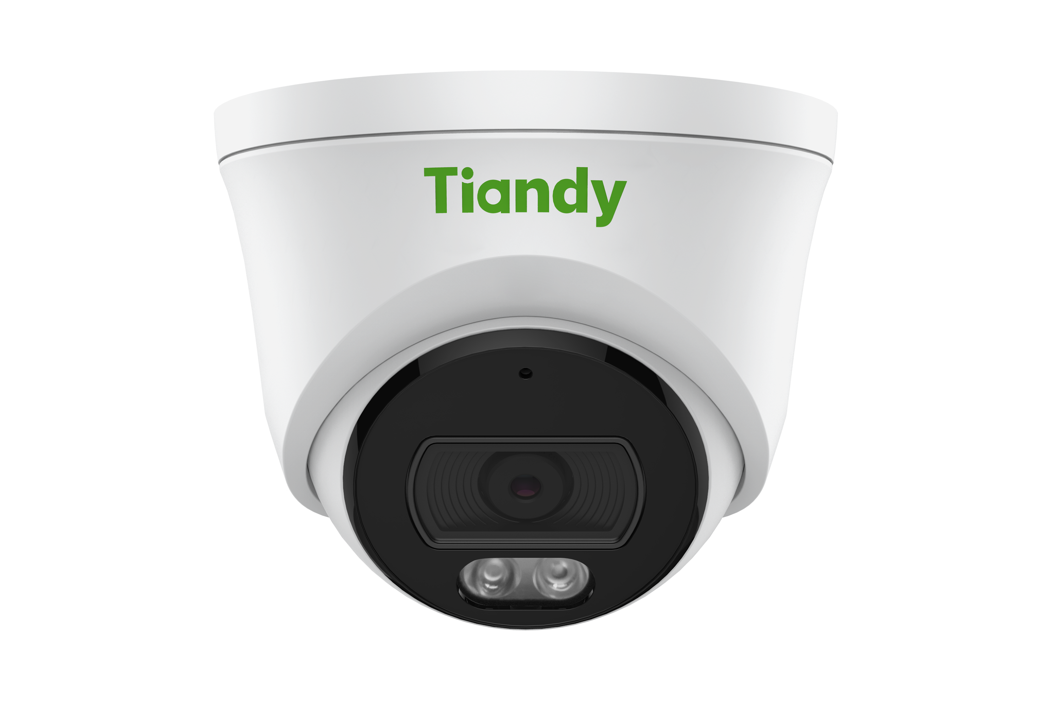
KEY FEATURES
• Metal+plastic housing
• Up to 5MP,3072×1728@30fps
• S+265/H.265/H.264B/H.264M/H.264H
• Color:0.002Lux@(F1.6,AGC ON),B/W:0Lux with IR
• IR range up to 30m
• 1×Built-in Mic
• Support microSD/microSDHC/microSDXC card,up to 512GB
• Support human/vehicle classification
• Operating conditions -35℃~65℃(-31℉~149℉), ≤95%RH
• DC12V±25%,Max. 4.5W, PoE:IEEE 802.3af,Max. 5W

• IP67
SPECIFICATIONS
Camera
Image Sensor | 1/2.7"CMOS
Min. Illumination | Color:0.002Lux@(F1.6,AGC ON),B/W:0Lux with IR
Shutter Time | 1s~1/100000s
Day&Night | IR-cut filter with auto switch (ICR)
Smart IR | Yes
WDR | 120dB
S/N | >39dB
Angle Adjustment | 0~340°(P); 0~75°(T); 0~360°(R)

Lens
Lens Type | Fixed focal lens
Focal Length | 2.8mm
Lens Mount | M12
Aperture Range | F1.6
Aperture Type | Fixed
Field of View | 109°(H); 59°(V); 125.4°(D)

DORI Distance | Detect:56m  Observe:22m  Recognize:11m

Identify:5.6m

Illuminator
IR LEDs | 2
IR Distance | Up to 30m

Wavelength | 850nm
White LEDs | 2
Whitelight Distance | 15m

Compression Standard
Video Compression | S+265/H.265/H.264B/H.264M/H.264H
Video Bit Rate | 32k~6Mbps
Audio Compression | G.711A/G.711U/ADPCM_D
Audio Sampling Rate | 8kHz/32kHz/48kHz

Image
Max. Resolution | 5MP,3072×1728@30fps
Main Stream | PAL:25fps(3072×1728, 2688×1520, 2560×1440, 2304×1296, 1920×1080, 1280×720) NTSC:30fps(3072×1728, 2688×1520, 2560×1440, 2304×1296, 1920×1080, 1280×720)
Sub Stream | PAL:25fps(704×576, 704×288, 640×360, 352×288) NTSC:30fps(704×480, 704×240, 640×360, 352×240)
BLC | Yes
HLC | Yes
AGC | Yes
3D DNR | Yes
White Balance | Auto/Semi-Auto/Manual/Sunshine/Nature Light/Warmlight Lamp/Daylight Lamp/ Filament Lamp/Lock White Balance
ROI | 8 rectangular static areas
OSD | Overlay of additional characters in 1 regions, 1 line, with a maximum of 48 characters or 16 Chinese characters per region; 16*16/32*32/48*48/64*64/96*96; Lattice
Privacy Mask | 4 black static areas
Defog | Yes

Feature
General Alarm | Motion Detection; Mask Alarm
Exceptions Alarm | Disk Full; Disk R/W Error; IP Address Conflict; Network Disconnection

Linkage Method | Trigger Recording; Trigger Capture; Notify Surveillance Center
Video Analytics | Human/Vehicle Classification; Tripwire; Perimeter
Rules of Behavior Analyse In 1 Scene | 2

Network
ANR | Yes
Protocols | RTSP; HTTP; HTTPS; TCP; UDP; UPnP; ICMP; SNMP v1\v2\v3; DHCP; DNS; DDNS; Easy DDNS; NTP; TLS v1.2; QoS; IPv4; SSH; Unicast; Multicast; ARP; FTP
System Compatibility | P2P(Mutually exclusive with Profile G); ONVIF(Profile S/T/G) ; SDK; CGI; Milestone
Remote Connection | ≤2
Client | Easy7 VMS
Moblie Client | EasyLive Plus
Web | IE10+; Firefox52+; Edge89+; Safari11+; Chrome57+

Interface
Communication Interface | 1×RJ-45 (10/100 Base-T)
Built-in Mic | 1×Built-in Mic
Reset Button | Yes(Built-in)
On-board Storage | Support microSD/microSDHC/microSDXC card,up to 512GB
RTC | Yes

General

Web Client Language | 20 languages  Simple Chinese/Traditional Chinese/English/Spanish/Korean/Italian/Turkish/Russian/ Thai/French/Polish/Dutch/Hebrew/Arabic/Vietnamese/German/Ukrainian/Portuguese/

 | Albanian/Greek
Operating Temperature | -35℃~65℃(-31℉~149℉)
Operating Humidity | ≤95%RH
Storage Temperature | -35℃~65℃(-31℉~149℉)
Storage Humidity | 10%~95%RH(non-condensing)

Power Supply | DC12V±25%,Max. 4.5W; PoE:IEEE 802.3af,Max. 5W
Protection | Surge4000V; ESD6000V; IP67
Boundary Dimensions | 117(L)117(W)96(H)mm
Package Dimensions | 140(L)140(W)120(H)mm
GrossWeight | 0.466kg
DIMENSIONS (Unit: mm)
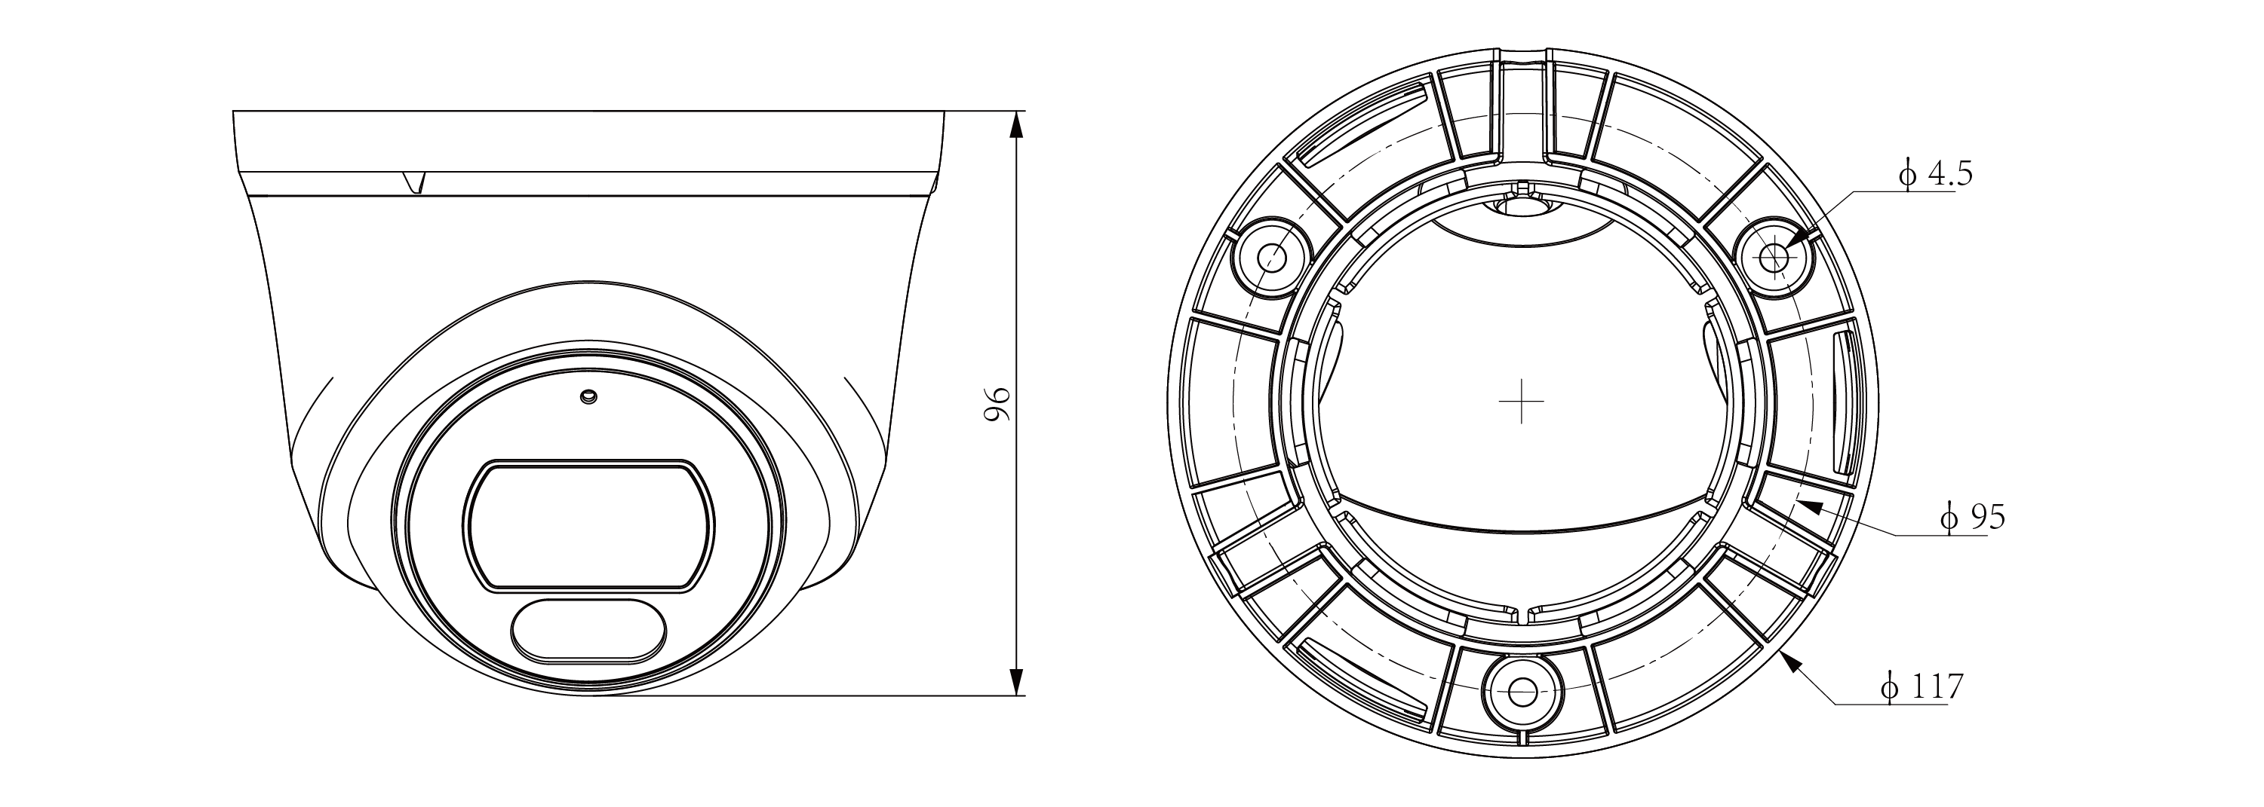
Assembly diagram of Junction Box
