TC-H324S 323IA
PTZ Camera
Pro Series
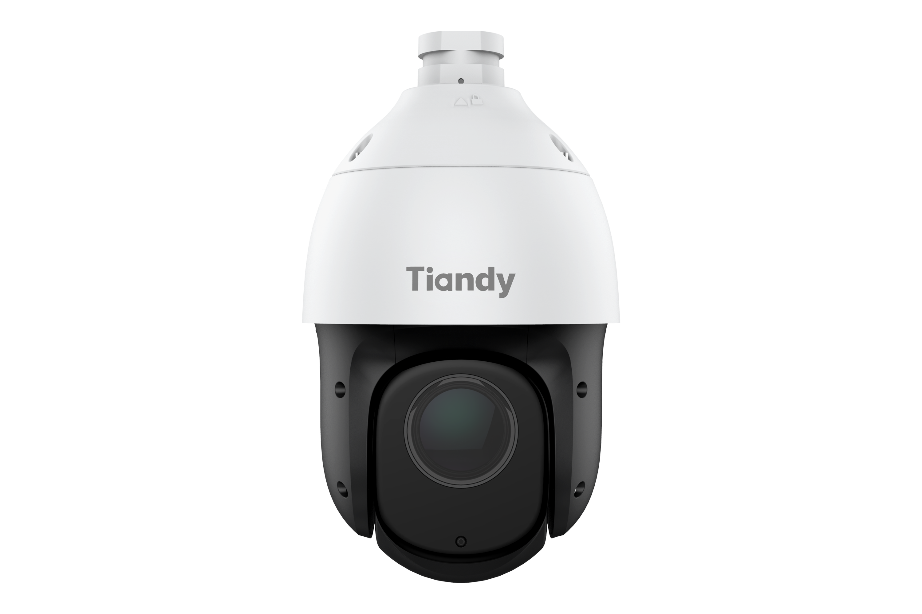
KEY FEATURES
Up to 2MP,1920×1080@30fps
Color:0.001lux@ (F1.5,AGC ON),B/W:0lux with IR
S+265/H.265/H.264B/H.264M/H.264H/Motion JPEG
Optical zoom 23X
IR range up to 150m
Support microSD/microSDHC/microSDXC card,up to 512GB Support smart surveillance
Support human/vehicle classification
Operating conditions -30℃~65℃(-22℉~149℉), ≤95%RH

DC12V±10%, PoE:IEEE 802.3at
IP66
SPECIFICATIONS
Camera
Image Sensor | 1/2.8"CMOS
Min. Illumination | Color:0.001lux@ (F1.5,AGC ON),B/W:0lux with IR
Shutter Time | 1s~1/100000s
Day&Night | IR-cut filter with auto switch (ICR)
Smart IR | Yes
WDR | 120dB
S/N | 42dB
Lens
Focal Length | 5mm~115mm
Optical Zoom | 23X
Zoom Speed | <5s
Aperture Range | F1.5~F3.0
Aperture Type | Auto(P-Iris)
Field of View | 55.8°~3.2°(H); 32.2°~1.8°(V); 61°~3.64°(D)
Focus Control | Auto/Semi-auto/Manual
Close Focus Distance | 1000mm~1500mm
DORI Distance | Detect:1351m  Observe:536m  Recognize:270m  Identify:135m
Pan&Tilt
Pan Range | 0~360°(P)

Pan Speed | Manual Speed:0.1°～80°/s  Preset Speed:80°/s
Tilt Range | -16°~90°(T) (Default -3°~90°(T))
Tilt Speed | Manual Speed:0.1°～80°/s  Preset:80°/s
3D Position | Yes
Preset | 500
Cruise | 16(up to 32 presets per cruise)
Scan | 8
Pattern | 8,each with 600s memory or 1000 orders
Scheduled Task | Preset,Cruise,Scan,Pattern
North Point | Yes(Manual setting)
Power-off Memory | Yes
Illuminator
IR LEDs | 7
IR Distance | Up to 150m
Wavelength | 850nm
IR Irradiation Angle | Yes
Compression Standard
Video Compression | S+265/H.265/H.264B/H.264M/H.264H/Motion JPEG
Video Bit Rate | 32Kbps~16Mbps
Audio Compression | G.711A/G.711U/ADPCM_D/AAC_LC
Audio Sampling Rate | 8kHz/32kHz/48kHz
Image
Max. Resolution | 2MP,1920×1080@30fps
Main Stream | PAL:25fps(1920×1080,1280×720,640×480,704×576) NTSC:30fps(1920×1080,1280×720,640×480,704×480)
Sub Stream | PAL:25fps(704×576,704×288,640×360,352×288) NTSC:30fps(704×480,704×240,640×360,352×240)

Third Stream | PAL:25fps(352×288)  NTSC:30fps(352×240)
BLC | Yes
HLC | Yes
AGC | Yes
3DNR | Yes
White Balance | Auto/Semi-Auto/Manual/Sunshine/Nature Light/Warmlight Lamp/Daylight Lamp/ Filament Lamp/Lock White Balance
ROI | 7 Dynamic Areas for Both Main and Sub Stream
OSD | 5 regions(Each region can have a maximum of 127 characters ,up to 1 line); 16*16/24*24/32*32/48*48/64*64/adaptable size; Vector/Lattice
Defog | Yes
Flip | Normal/Horizontal Mirror/Vertical Mirror/Inverted Flip
Regional Exposure | Yes
Regional Focus | Yes
Demist | Yes
Feature
General Alarm | Motion Detection; Mask Alarm; Alarm Input
Exceptions Alarm | Voltage Alarm; Disk Full; Disk R/W Error; Recording Exception; IP Address Conflict; MAC Address Conflict; FTP Server Exception ; Network cable disconnected
Linkage Method | Send Email; Trigger Sound; Trigger Recording; Trigger Capture; Notify Surveillance Center; Alarm Output
Video Analytics | Human/Vehicle Classification; Tripwire; Double Tripwire; Perimeter; Object Abandon; Object Missing; Heatmap; Video Abnormal; Audio Abnormal
Network
ANR | Yes
Protocols | RTSP; RTMP; HTTP; HTTPS; TCP/IP; UDP; UPnP; ICMP; IGMP; SNMP v1\v2\v3; DHCP; DNS; DDNS; Easy DDNS; NTP; SMTP; TLS v1.2; SSL; 802.1x; QoS; IPv4; IPv6; PPPoE; SSH; Unicast; Multicast; ARP; RTP; SRTP; FTP; SFTP
System Compatibility | P2P; ONVIF(Profile S/T/G/M); SDK; CGI; Milestone; RTSP; RTMP; HTTP PUSH
Remote Connection | ≤2

User/Host | 32users,  Level 4:Admin/Browse/Browse+Control/Browse+Control+Set
Client | Easy7 VMS
Mobile Client | EasyLive Plus
Web | IE10+; Firefox52+; Edge89+; Safari11+; Chrome57+
Interface
Communication Interface | 1*RJ45 (10/100Base-T)
Audio I/O | 1*Input Impedance 1kΩ,2.0~2.4Vp-p; 1*Output Impedance 600Ω
Alarm I/O | 1*Switching; 1*Switching,Voltage≤DC24V,Current≤1A
Reset Button | Yes
On-board Storage | Support microSD/microSDHC/microSDXC card,up to 512GB
General
Web Client Language | 19 languages  Simple Chinese/English/Traditional Chinese/Spanish/Italian/ Korean/Turkish/Russian/ Thai/ Polish/French/Dutch/ Hebraism/Vietnamese/Arabic/German/ Ukrainian / Portuguese/Albanian
Operating Temperature | -30℃~65℃(-22℉~149℉)
Operating Humidity | ≤95%RH
Storage Temperature | -30℃~65℃(-22℉~149℉)
Storage Humidity | 10%~95%RH(non-condensing)
Power Supply | DC12V±10%; PoE:IEEE 802.3at
Power Consumption | 7.15W(IR OFF) ; 18.5W(IR ON)
Protection | Surge4000V; ESD6000V; IP66
Material | Metal+plastic
Boundary Dimensions | 161(D)276(H)mm
Package Dimensions | 260(L)260(W)465(H)mm
GrossWeight | 3.8kg
NetWeight | 2.1kg

DIMENSIONS (Unit: mm)
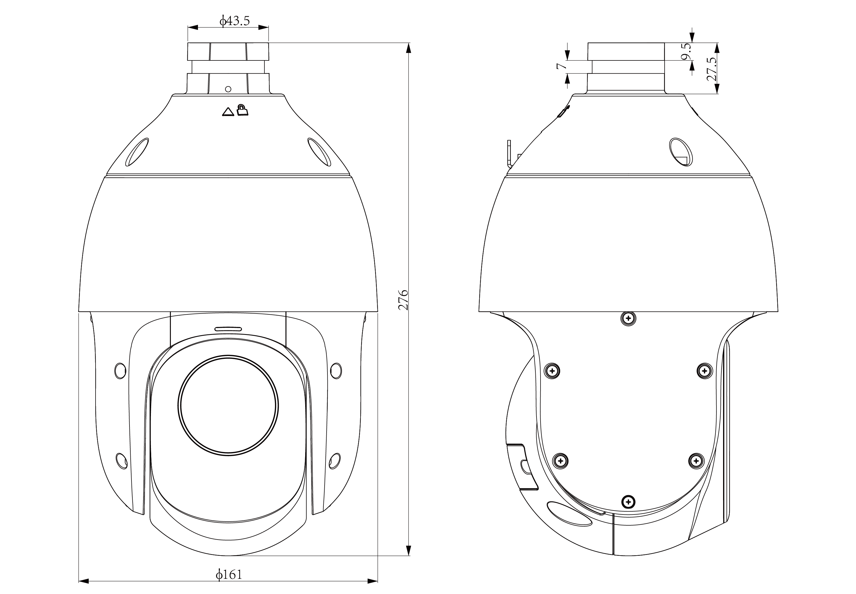
Assembly diagram of Junction Box
