
TC-R3110 Spec:I/B/L/Eu/V1.1 1HDD 10ch NVR
SK Series
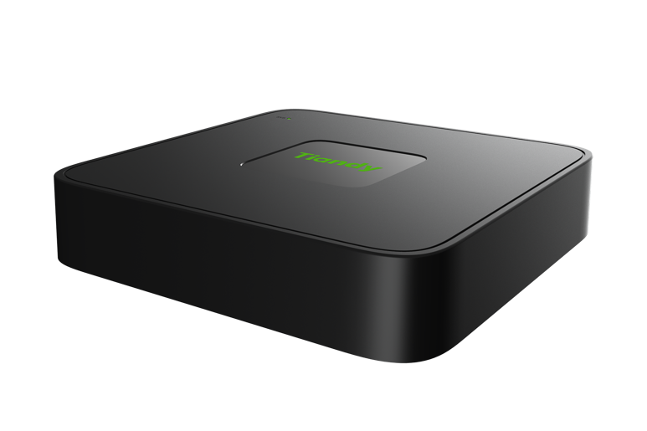
KEY FEATURES
Up to 10-ch IP camera accesses
Incoming/Outgoing bandwidth: 60Mbps/40Mbps
S+265, H.265, S+264, H.264, S+265 V2.0 video formats Max. decoding capability: 8MP(30fps)×1 or 1080P(30fps)×6 4-ch synchronous playback
Up to 8 TB capacity for each HDD
Simultaneous HDMI and VGA outputs
HDMI output at up to 4K resolution
2026.08.03

1×RJ-45, 10/100 Mbps self-adaptive Ethernet port
S+ 265 compression effectively reduces the storage space by up to 75% Support cloud upgrade
SPECIFICATIONS
Video and Audio
Access Channel | 10
Incoming Bandwidth | 60Mbps
Outgoing Bandwidth | 40Mbps
Resolution | 8MP/6MP/5MP/4MP/3MP/1080P/UXGA/720P/VGA/4CIF/DCIF/2CIF/CIF/QCIF
Preview Decoding Capability | 8MP(30fps)×1, 6MP(30fps)×2, 5MP(30fps)×2, 4MP(30fps)×3, 3MP(30fps)×4, 1080P(30fps)×6, 720P(30fps)×10, 4CIF(30fps)×10
Playback Decoding Capability | 8MP(30fps)×1, 6MP(30fps)×2, 5MP(30fps)×2, 4MP(30fps)×3, 3MP(30fps)×4, 1080P(30fps)×4, 720P(30fps)×4, 4CIF(30fps)×4
Third-party Camera Access | ONVIF(Profile S/T); RTSP
HDMI Output | HDMI: 1024×768(60Hz), (720P )1280×720(50Hz/60Hz), 1280×800(60Hz), 1366×768(60Hz), 1440×900(60Hz), (1080P)1920×1080(50Hz/60Hz), (4K)3840×2160(30Hz)
VGA Output | VGA: 1024×768(60Hz), (720P )1280×720(50Hz/60Hz), 1280×800(60Hz), 1366×768(60Hz), 1440×900(60Hz), (1080P)1920×1080(50Hz/60Hz)
Multi-screen Display | Simultaneous Output:  VGA: 1/2A/2B/3/4/5/6/7/8/9/10  HDMI: 1/2A/2B/3/4/5/6/7/8/9/10
Compression Standard
Video Compression | S+265; H.265; S+264; H.264; S+265 V2.0
Audio Compression | G.711A; G.711U; ADPCM_D
Stream Type | Video; Video & Audio
Network
2026.08.03

Network Protocol | 802.1X; ARP; DDNS; DHCP; DNS; Easy DDNS; HTTP; HTTPS; ICMP; IGMP; IPv4; IPv6; Multicast; NTP; RTCP; RTP; RTSP; SMTP; SRTP; SSH; TLSv1.2; TCP; UDP; Unicast; UPnP
Client | Easy7 VMS (Win, MAC OS)
Mobile Client | EasyLive Plus (Android, iOS)
System Compatibility | RTSP; CGI; SDK; P2P
Web | IE10+; Firefox52+; Edge89+; Safari11+; Chrome57+
Recording Playback
Multi-channel Playback | 4
Record Mode | Manual Recording; Alarm Recording; Schedule Recording; Smart Storage Mode
Storage Method | Local HDD
Backup | USB storage device
Playback Function | Play/Pause/Stop/Slow/Speed/Backwards 30s/Forwards 30s/Full Screen/Backup (Video Editing)/ Step/Digital Zoom/Instant Replay
Dual Stream Record | Yes
Alarm
General Alarm | Motion Detection; Mask Alarm; Alarm Input(IPC)
Exceptions Alarm | Video Loss; Network Disconnected; No Disk; Illegal Access; Disk group space alert; Disk Full; Disk R/W Error; Recording Abnormal; Abnormal found in smart of disk; Abnormal temperature of the disk; Voltage Alarm(IPC); RTC Failure; IP Address Conflict; MAC Address Conflict; Disk Overload
Intelligent Analytics
AI by Camera | Tripwire; Double Tripwire; Perimeter; Object Abandon; Object Missing; Running; Parking; Loitering; Video Abnormal; Audio Abnormal; On Duty Detection; Crowd Detection; Smart Alarm; Human/ Vehicle Classification
Search
VCA Search | Early-warning Search; Behavior Search; Duty Search; Smart Motion Detection
Storage
HDD Capacity | Up to 8 TB capacity for each HDD
Disk Group | 1 Disk Group
External Port
2026.08.03

USB | 2×USB2.0
HDMI | 1×HDMI(supports up to 4K resolution output)
VGA | 1×VGA
Network Interface | 1×RJ-45, 10/100 Mbps self-adaptive Ethernet port
SATA | 1×SATA interface
General
UI Language | English; Spanish; Italian; Turkish; French; Polish; Hebrew; German; Portuguese; Greek
Power Supply | DC12V
Power Consumption | <10W(HDD not included, idling)
NetWeight | 0.4 kg
GrossWeight | 0.7 kg
Boundary Dimensions | 201(L)202(W)43(H)mm
Package Dimensions | 315(L)70(W)235(H)mm
Operating Temperature | -10℃~+55℃ (+14℉~+131℉)
Operating Humidity | 10%~90%RH (non-condensing)
Storage Temperature | -20℃~+60℃ (-4℉~+140℉)
Package Kit | Network Video Recorder*1; Screw Pack*1; Mouse*1; European Standard Power Adapter(DC12V 1.5A)*1; Instructions*1; Parts List*1
2026.08.03

DIMENSIONS (Unit: mm)
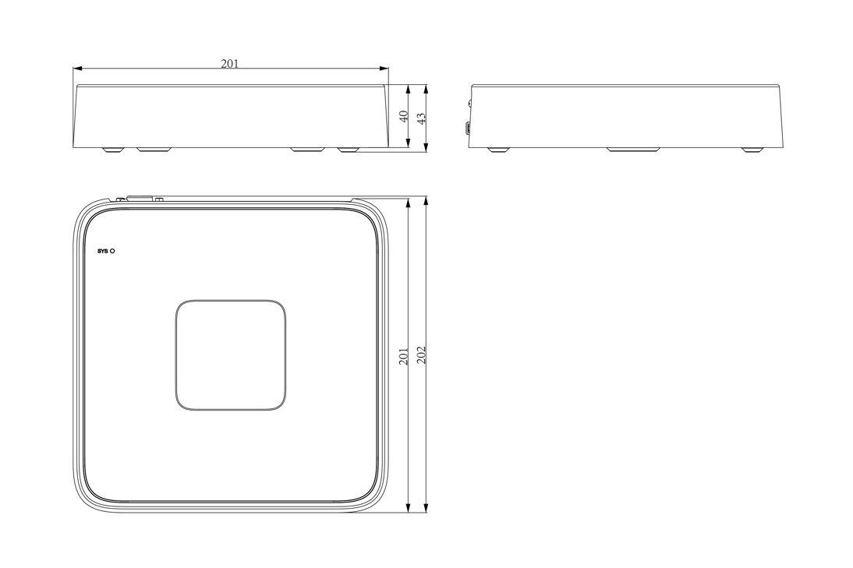
2026.08.03

Physical Interfaces
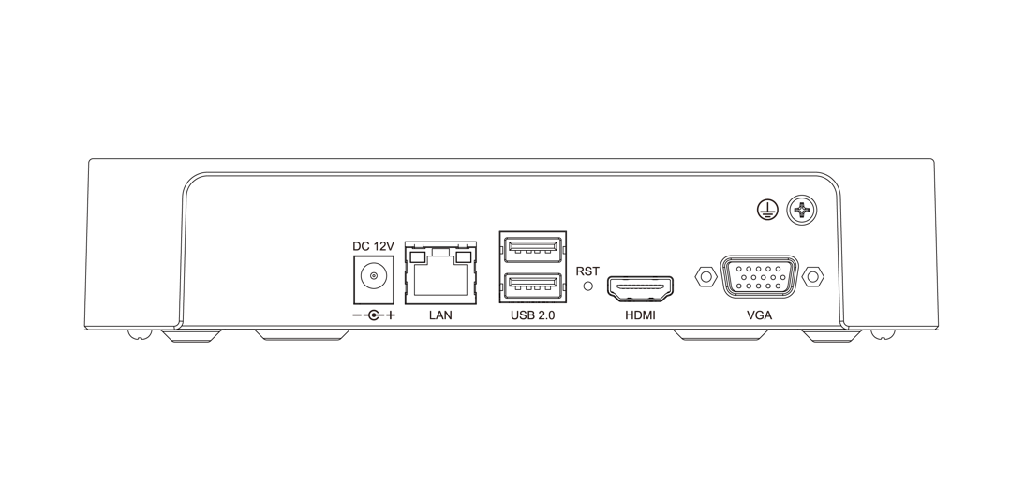
2026.08.03

