
TC-C35MS 4LHB-27135
Dome Camera
LK
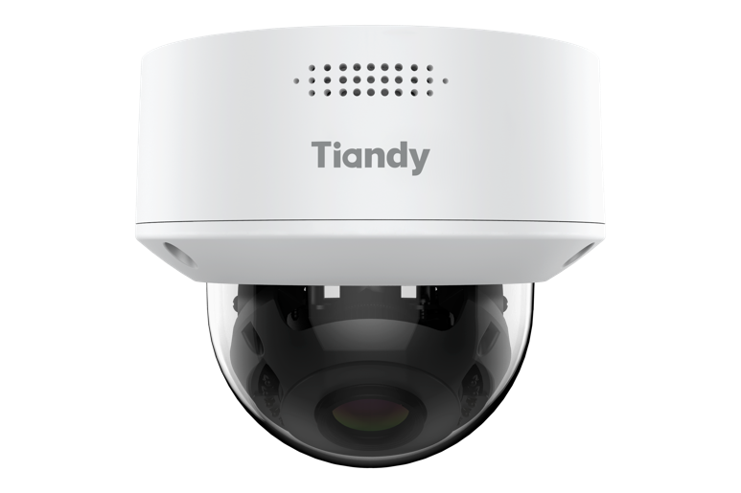
KEY FEATURES
Metal housing
Up to 5MP,2880×1620@30fps
S+265/H.265/H.264B/H.264M/H.264H/Motion JPEG
Color:0.002Lux@(F1.6,AGC ON),B/W:0Lux with IR
IR range up to 50m
1×Built-in Mic
Support microSD/microSDHC/microSDXC card,up to 512GB Support smart surveillance, face capture
2026.03.20

Support human/vehicle/non-motor vehicle/pet(cat、dog) classification Operating conditions -35℃~65℃(-31℉~149℉), ≤95%RH
DC12V±25%,Max. 8.5W, PoE:IEEE 802.3at,Max. 9.5W
IP66, IK10
SPECIFICATIONS
Camera
Image Sensor | 1/2.7"CMOS
Min. Illumination | Color:0.002Lux@(F1.6,AGC ON),B/W:0Lux with IR
Shutter Time | 1s~1/100000s
Day&Night | IR-cut filter with auto switch (ICR)
Smart IR | Yes
WDR | 120dB,True WDR(TWDR)
S/N | >42dB
Angle Adjustment | 0~345°(P); 0~90°(T); 0~350°(R)
Lens
Lens Type | Motorized
Focal Length | 2.7~13.5mm
Lens Mount | Φ14
Aperture Range | F1.6
Aperture Type | Fixed
Field of View | 102°~33.2°(H); 56.7°~18.7°(V); 125.7°~38°(D)
DORI Distance | Detect:60m~220m  Observe:24m~87m  Recognize:12m~44m  Identify:6m~22m
Illuminator
2026.03.20

IR LEDs | 16
IR Distance | Up to 50m
Wavelength | 850nm
White LEDs | 8
Whitelight Distance | 15m
Compression Standard
Video Compression | S+265/H.265/H.264B/H.264M/H.264H/Motion JPEG
Video Bit Rate | 32k~16Mbps
Audio Compression | G.711A/G.711U/ADPCM_D/AAC_LC
Audio Sampling Rate | 8kHz/32kHz/48kHz
Image
Max. Resolution | 5MP,2880×1620@30fps
Main Stream | PAL:25fps(2880×1620,2688×1520, 2560×1440, 2304×1296)50fps(1920×1080, 1280×720) NTSC:30fps(2880×1620,2688×1520, 2560×1440, 2304×1296)60fps(1920×1080, 1280×720)
Sub Stream | PAL:25fps(704×576, 704×288, 640×360, 352×288) NTSC:30fps(704×480, 704×240, 640×360, 352×240)
Third Stream | PAL:25fps(1280x720,704x576,704x288,352x288, 640×480) NTSC:30fps(1280x720,704x480,704x240,352x240, 640×480)
BLC | Yes
HLC | Yes
AGC | Yes
3D DNR | Yes
White Balance | Auto/Semi-Auto/Manual/Sunshine/Nature Light/Warmlight Lamp/Daylight Lamp/Filament Lamp/ Lock White Balance
ROI | 8 rectangular static areas
Corridor Mode | Yes
OSD | Overlay of additional characters in 5 regions,2 line, with a maximum of 127 characters or 42 Chinese characters per region; 16*16/24*24/32*32/48*48/64*64/96*96,Default Adaptive; Vector/ Lattice
2026.03.20

Picture Overlay | 1*200x200 size BMP 24 color bit image overlay
Privacy Mask | 4 black static areas
Defog | Yes
Feature
General Alarm | Motion Detection; Mask Alarm; Alarm Input
Exceptions Alarm | Voltage Alarm; Disk Full; Disk R/W Error; IP Address Conflict; MAC Address Conflict; FTP Server Exception ; Network Disconnection; No Disk; Illegal Access
Linkage Method | Send Email; Trigger Sound; Trigger Warmlight; Trigger Recording; Trigger Capture; Notify Surveillance Center; Alarm Output; Trigger smart light
Video Analytics | Human/Vehicle/Non-motor Vehicle/Pet(Cat、Dog) Classification; Tripwire; Perimeter; Video Abnormal; Audio Abnormal
Rules of Behavior Analyse In 1 Scene | 8
Face Mode | Face Capture
Face Detection Performance | Detect up to 8 faces at the same scene; Capture up to4 faces at the same scene
False Rate of Face Capture | ≤1%
Face Duplicate Capture Rate | ≤20%（Continuous 4-person scene and below）
Mask Attribute Linkage Alarm | Mask Attribute Linkage Alarm
Image Push Strategy | Image Push Strategy
Image Push Interval | Image Push Interval
Capture Mode | Capture Mode
Face Capture | Face Capture
Background Image Resolution | 1920*1080
Background Image OSD Overlay | video streamOSD/customize
Network
ANR | Yes
2026.03.20

Protocols | RTSP; RTMP; HTTP; HTTPS; TCP; UDP; UPnP; ICMP; IGMP; SNMP v1\v2\v3; DHCP; DNS; DDNS; Easy DDNS; NTP; SMTP; TLS v1.2; SSL; 802.1X; QoS; IPv4; IPv6; PPPoE; SSH; Unicast; Multicast; RTCP; ARP; SRTP; FTP; SFTP; NAS
System Compatibility | ONVIF(Profile S/T/G/M) ; SDK; CGI; Milestone
Remote Connection | Up to 7 channels
Client | Easy7 VMS
Mobile Client | EasyLive Plus
Web | IE10+; Firefox52+; Edge89+; Safari11+; Chrome57+
Interface
Communication Interface | 1×RJ-45 (10/100 Base-T)
Audio I/O | 1×input, two-core , max. input amplitude:3.3 Vpp, input impedance:1 KΩ, interface type:non-equilibrium; 1×output, two-core, max. output amplitude:3.3 Vpp, output impedance:100 Ω, interface type: non-equilibrium
Alarm I/O | 1×input,TTL,3mA,3.3VDC; 1×output,TTL,30mA,12VDC
Built-in Mic | 1×Built-in Mic
Reset Button | Yes
On-board Storage | Support microSD/microSDHC/microSDXC card,up to 512GB
RTC | Yes
General
Web Client Language | 20 languages  Simple Chinese/Traditional Chinese/English/Spanish/Korean/Italian/Turkish/Russian/Thai/French/ Polish/Dutch/Hebrew/Arabic/Vietnamese/German/Ukrainian/Portuguese/Albanian/Greek
Operating Temperature | -35℃~65℃(-31℉~149℉)
Operating Humidity | ≤95%RH
Storage Temperature | -40℃~65℃(-40℉~149℉)
Storage Humidity | 10%~95%RH(non-condensing)
Power Supply | DC12V±25%,Max. 8.5W; PoE:IEEE 802.3at,Max. 9.5W
Protection | Surge4000V; ESD6000V; IP66; IK10
Boundary Dimensions | 143(L)143(W)123(H)mm
2026.03.20

Package Dimensions | 250(L)180(W)175(H)mm
GrossWeight | 1.18kg
NetWeight | 0.9kg
DIMENSIONS (Unit: mm)
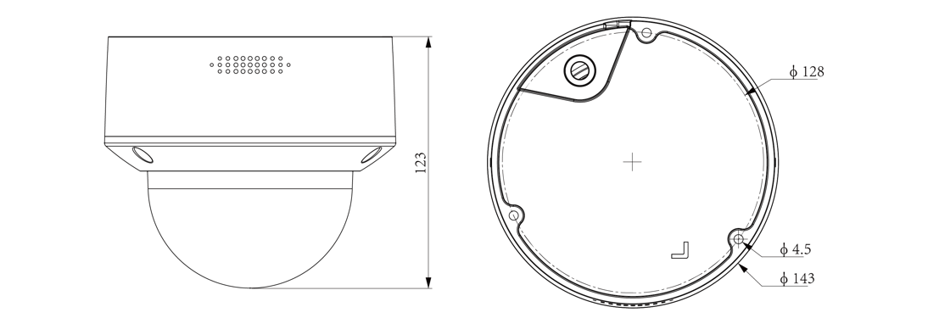
2026.03.20

Assembly diagram of Junction Box
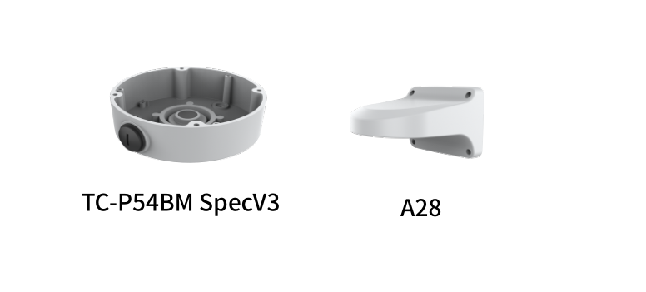
2026.03.20

