
TC-C38XQ 4LHC-28
Turret Camera
LK
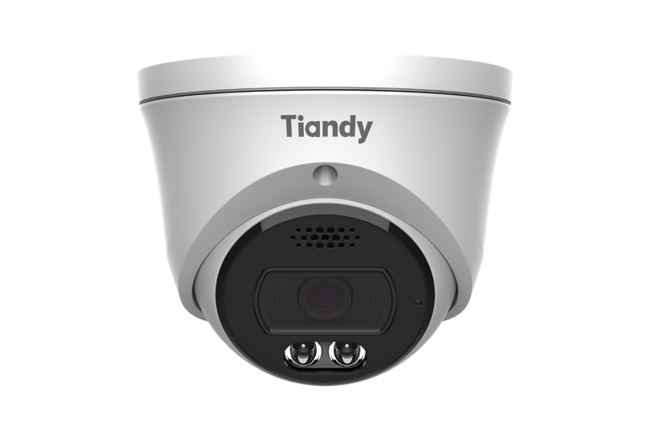
KEY FEATURES
Metal housing
Up to 8MP,3840×2160@30fps
S+265/H.265/H.264B/H.264M/H.264H/Motion JPEG
Color:0.002Lux@(F1.6,AGC ON),B/W:0Lux with IR
IR range up to 50m
1×Built-in Mic, 1×Built-in Loudspeaker
Support microSD/microSDHC/microSDXC card,up to 512GB Support smart surveillance
2026.03.20

Support human/vehicle/non-motor vehicle/pet(cat、dog) classification Operating conditions -40℃~65℃(-40℉~149℉), ≤95%RH
DC12V±25%,Max. 10W, PoE:IEEE 802.3at,Max. 11W
IP66
SPECIFICATIONS
Camera
Image Sensor | 1/2.8"CMOS
Min. Illumination | Color:0.002Lux@(F1.6,AGC ON),B/W:0Lux with IR
Shutter Time | 1s~1/100000s
Day&Night | IR-cut filter with auto switch (ICR)
Smart IR | Yes
WDR | 120dB,True WDR(TWDR)
S/N | >42dB
Angle Adjustment | 0~340°(P); 0~75°(T); 0~360°(R)
Lens
Lens Type | Fixed focal lens
Focal Length | 2.8mm
Lens Mount | M12
Aperture Range | F1.6
Aperture Type | Fixed
Field of View | 105°(H); 57°(V); 120°(D)
DORI Distance | Detect:77m  Observe:30.5m  Recognize:15m  Identify:7.5m
Illuminator
2026.03.20

IR LEDs | 2
IR Distance | Up to 50m
Wavelength | 850nm
White LEDs | 2
Whitelight Distance | 30m
Red and Blue Alarm Flash | Red and Blue Light
Compression Standard
Video Compression | S+265/H.265/H.264B/H.264M/H.264H/Motion JPEG
Video Bit Rate | 32k~16Mbps
Audio Compression | G.711A/G.711U/ADPCM_D/AAC_LC
Audio Sampling Rate | 8kHz/32kHz/48kHz
Image
Max. Resolution | 8MP,3840×2160@30fps
Main Stream | PAL:25fps(3840×2160, 3200×1800,2560×1440, 2304×1296)50fps(1920×1080, 1280×720) NTSC:30fps(3840×2160, 3200×1800,2560×1440, 2304×1296)60fps(1920×1080, 1280×720)
Sub Stream | PAL:25fps(704×576, 704×288, 640×360, 352×288) NTSC:30fps(704×480, 704×240, 640×360, 352×240)
Third Stream | PAL:25fps(704×576, 704×288, 352×288, 640×480) NTSC:30fps(704×480, 704×240, 352×240, 640×480)
BLC | Yes
HLC | Yes
AGC | Yes
3D DNR | Yes
White Balance | Auto/Semi-Auto/Manual/Sunshine/Nature Light/Warmlight Lamp/Daylight Lamp/Filament Lamp/ Lock White Balance
ROI | 8 rectangular static areas
Corridor Mode | Yes
2026.03.20

OSD | Overlay of additional characters in 5 regions,2 line, with a maximum of 127 characters or 42 Chinese characters per region; 16*16/24*24/32*32/48*48/64*64/96*96,Default Adaptive; Vector/ Lattice
Picture Overlay | 1*200x200 size BMP 24 color bit image overlay
Privacy Mask | 4 black static areas
Defog | Yes
Feature
General Alarm | Motion Detection; Mask Alarm; Alarm Input
Exceptions Alarm | Voltage Alarm; Disk Full; Disk R/W Error; IP Address Conflict; MAC Address Conflict; FTP Server Exception ; Network Disconnection; No Disk; Illegal Access
Linkage Method | Send Email; Trigger Sound; Trigger Warmlight; Trigger Recording; Trigger Capture; Notify Surveillance Center; Alarm Output; Trigger red and blue light ; Trigger smart light
Video Analytics | Human/Vehicle/Non-motor Vehicle/Pet(Cat、Dog) Classification; Tripwire; Double Tripwire; Perimeter; Object Abandon; Object Missing; Heatmap; Loitering; Running; Parking; People Counting; Crowed Detection; Safety Helmet Detection; On Duty Detection; Video Abnormal; Audio Abnormal
Rules of Behavior Analyse In 1 Scene | 8
Early Warning(EW) | Early Warning(EW)
Network
ANR | Yes
Protocols | RTSP; RTMP; HTTP; HTTPS; TCP; UDP; UPnP; ICMP; IGMP; SNMP v1\v2\v3; DHCP; DNS; DDNS; Easy DDNS; NTP; SMTP; TLS v1.2; SSL; 802.1X; QoS; IPv4; IPv6; PPPoE; SSH; Unicast; Multicast; RTCP; ARP; SRTP; FTP; SFTP; NAS
System Compatibility | ONVIF(Profile S/T/G/M) ; SDK; CGI; Milestone
Remote Connection | Up to 7 channels
Client | Easy7 VMS
Mobile Client | EasyLive Plus
Web | IE10+; Firefox52+; Edge89+; Safari11+; Chrome57+
Interface
Communication Interface | 1×RJ-45 (10/100 Base-T)
2026.03.20

Audio I/O | 1×input, two-core , max. input amplitude:3.3 Vpp, input impedance:1 KΩ, interface type:non-equilibrium; 1×output, two-core, max. output amplitude:3.3 Vpp, output impedance:100 Ω, interface type: non-equilibrium
Alarm I/O | 1×input,TTL,3mA,3.3VDC; 1×output,TTL,30mA,12VDC
Built-in Mic | 1×Built-in Mic
Built-in Speaker | 1×Built-in Loudspeaker
On-board Storage | Support microSD/microSDHC/microSDXC card,up to 512GB
RTC | Yes
General
Web Client Language | 20 languages  Simple Chinese/Traditional Chinese/English/Spanish/Korean/Italian/Turkish/Russian/Thai/French/ Polish/Dutch/Hebrew/Arabic/Vietnamese/German/Ukrainian/Portuguese/Albanian/Greek
Operating Temperature | -40℃~65℃(-40℉~149℉)
Operating Humidity | ≤95%RH
Storage Temperature | -40℃~65℃(-40℉~149℉)
Storage Humidity | 10%~95%RH(non-condensing)
Power Supply | DC12V±25%,Max. 10W; PoE:IEEE 802.3at,Max. 11W
Protection | Surge4000V; ESD6000V; IP66
Boundary Dimensions | 117(L)117(W)96(H)mm
Package Dimensions | 140(L)140(W)120(H)mm
GrossWeight | 0.66kg
NetWeight | 0.54kg
2026.03.20

DIMENSIONS (Unit: mm)
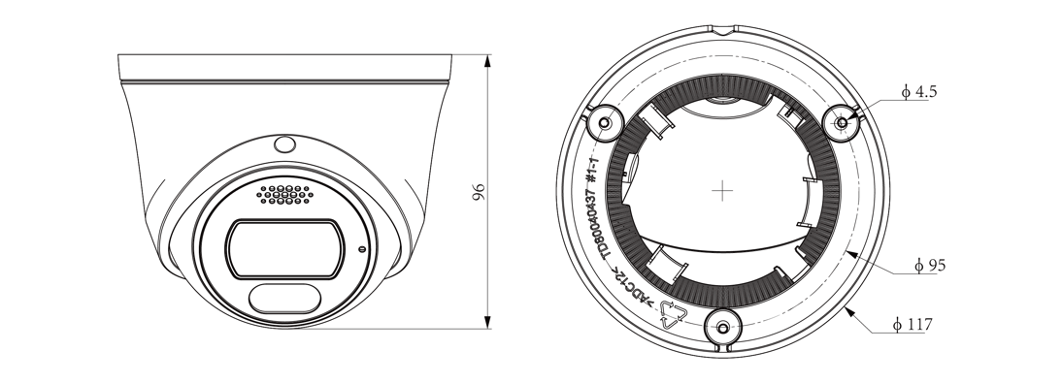
2026.03.20

Assembly diagram of Junction Box
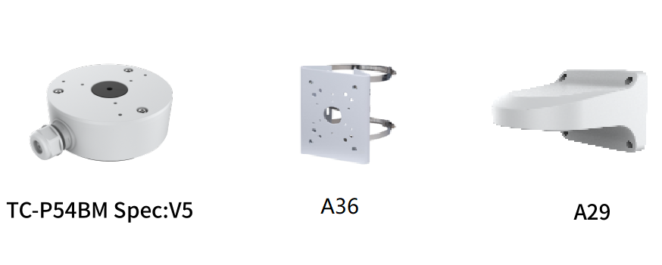
2026.03.20

