

Easy7 CMS
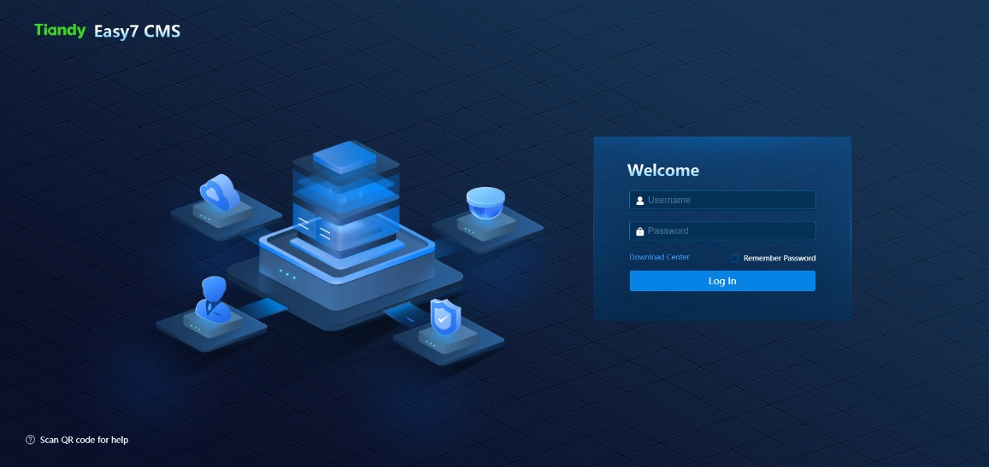
Software Version : V9.4.2

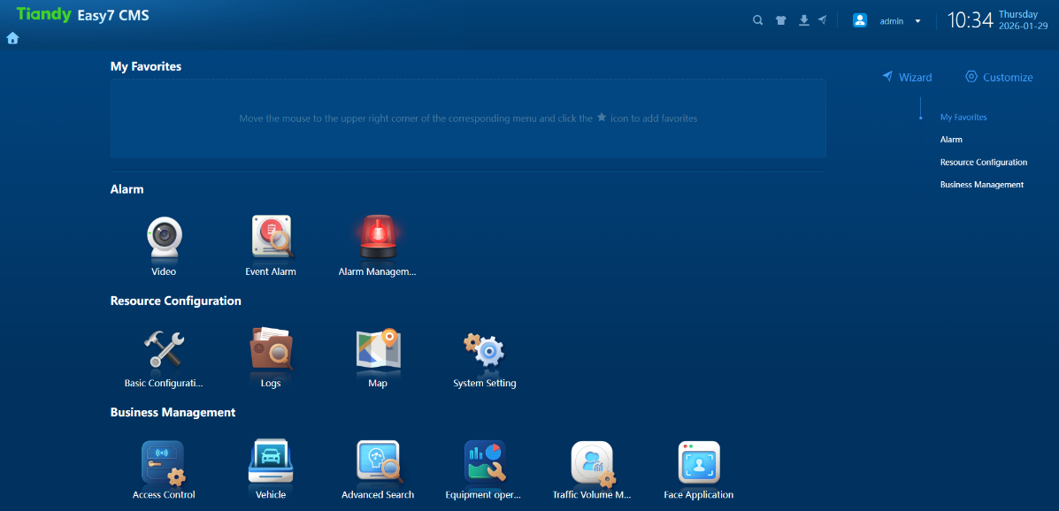

Key features:
System Manager
System Architecture & Scalability
- System Architecture – Server-client architecture with a web-based user interface for system configuration and management; no browser plugins required.
- System Scalability – Scalable system capacity starting from 30 channels and expandable up to 2,000 channels.
High Availability
- Management Server Redundancy – In event of Management Server failure, the standby Management Server shall take over the control, keeping all the operations intact.
Platform Customization
- Brand Customization – Platform name, welcome page background, system logo, and user interface color theme configurable per customer requirements.
- UI Layout Customization – Favorite view configuration, removal of unused application icons, and welcome screen layout customization.
Video Integrity & Security
- Video Authenticity – Native, tamper-proof video export with optional watermark embedding during recording.
- System Security – HTTPS-based web access, encrypted video export, and automatic screen lock after configurable user inactivity.
System Configuration & Management
- Configuration Wizard – Step-by-step guided workflow for basic surveillance system configuration.
- Network Flexibility – Multi-network and domain-based system access with configurable network settings.
- Time Synchronization – Local time server functionality for centralized time synchronization across connected devices.
Alarm Management
- Alarm Configuration – Event-based alarm configuration with flexible alarm handling mechanisms.
- Alarm Scheduling – Alarm arming and disarming based on time schedules and holiday templates.
- Alarm Severity Levels – Configurable alarm levels, including emergency, high, medium, and low priority.
Electronic Map (E-Map)
- Map Visualization – Camera and event visualization on locally uploaded maps or offline/online map services.
- Map-Based Playback – Live preview and playback directly from the E-Map interface without view switching.
- Multi-Camera Preview – Manual or area-based batch selection for previewing multiple cameras from E-Map.
Business & AI Applications
- Business Applications – Integrated personnel access control, vehicle access control, traffic management, and face management applications.
- Face Recognition Functions – Face search, high-frequency appearance analysis, stranger detection, and trajectory analysis.
- Vehicle Recognition Functions – License plate search, vehicle trajectory analysis, and restricted or unrestricted vehicle classification.
User, Site & Access Management
- User Role Management – Role-based user management with hierarchical access privilege levels.
- Access Restriction Control – User access restriction based on time validity, devices, channels, and functional features.
- Site Management – Multi-site management through organizational configuration.
- Access Control Personnel – Door-, zone-, and access group–based personnel access configuration.
Audit & Logging
- User Audit Logs – Detailed logs recording username, activity details, timestamps, and access IP addresses.
- Device Audit Logs – Device event logs with processing status, processing results, and query capabilities.

System Operations
Client Application
Lightweight plugin-based installable client station for live video preview, playback, E-Map access, and alarm handling.
Live Preview
- Device Tree View – Unified organizational, device, and E-Map tree structure with one-click online/offline filtering.
- Quick Operation Tools – One-click access to favorite views, patrol control, screenshots, local recording, split view, and instant playback.
- Resource Monitoring – Real-time monitoring of CPU, memory, and GPU utilization.
- Streaming Mode Control – Server-based or direct-device video streaming configuration for optimized bandwidth and resource usage.
- Toolbar Customization – Customizable camera toolbar with selectable quick-access functions.
- Video Format Selection – Download options for native tamper-proof format or standard MP4 format.
- Keyboard Control – Configurable keyboard shortcuts for PTZ control, snapshot capture, and other functions.
Playback
- Playback Tree View – Organizational and device tree structure with online/offline filtering.
- Search Criteria – Footage search by channel, organization, video type, storage location, and time range.
- Playback Modes – Forward, reverse, frame-by-frame, synchronous, asynchronous, and alarm-based playback.
- Footage Export – Clip-based, time-based, and alarm-based video download options.
Electronic Map (E-Map)
- Map Device View – Map-based visualization integrated with organizational and device hierarchy.
- Map Filtering – Device filtering for alarms, video channels, checkpoints, and access control points.
- Batch Device Selection – Multi-device selection using point, rectangle, circle, line, or polygon tools.
- Alarm Visualization – Blinking alarm indicators on maps with direct alarm silencing.
- Map Customization – Drawing tools, area marking, scale definition, and color customization.
Event Alarms
- Alarm Notification – Real-time visual alarm indicators with unattended alarm counters.
- Alarm Navigation – One-click access to alarm management interface displaying latest alarms.
- Multi-Level Alerts – Alarm notifications via pop-ups, fixed notifications, alarm lists, and audio alerts based on severity.
- Alarm Query – Historical alarm search by alarm type, event name, device, time, and processor.
- Alarm Processing – Detailed alarm view including alarm data, map location, snapshot, video playback, and handling actions.

Mobile Application
Access live video, playback recordings, and receive alarm notifications directly on your mobile device on the go. The same can be restricted to access the data in local network only or can connect over internet as well.

Detailed features：
Product Features
System Management
Device Management | Management of standard surveillance devices, including fixed and PTZ IP cameras, Panoramic Cameras, NVRs, Thermal Imaging Devices and Perimeter/Security Devices,
Device Management | Management of Face Surveillance Devices, including Automatic Face Capture Cameras and Face Recognition NVRs.
Device Management | Management of Vehicle Surveillance Devices, including Vehicle Capture Cameras and Traffic Control Servers.
Device Management | Management of Face Recognition Terminal Readers and Access Controllers.
Device Management | Management of People Counting Cameras.
Device Management | Management of various Video Application Services, including Centralized Storage, Database Application Services and Streaming Media Services.
Device Management | Time synchronization configuration for IPCs, NVRs, and storage servers.
User Permission Management | User-based permission assignments to control device’s access, monitoring, and configuration rights.
User Permission Management | Configurable user access controlling using time-based restrictions, dedicated IP restrictions or IP range whitelisting for platform login.
User Permission Management | User level configuration, with higher-level users granted priority control over devices.
User Permission Management | General User Access Privileges managed by Admin or Super Admin Account
Interface Customization | Supports customization, allowing for the reordering of functional components and the sequence of features within groups.
Alarm Management | Definition and configuration of specific alarm events based on operational requirements.
Alarm Management | Configuration of alarm name, active time, and descriptive information.
Alarm Management | Alarm triggering based on selected alarm types and severity levels – Emergency, High, Medium and Low Priority.
Alarm Management | Configuration of linkage response actions through intuitive action cards (e.g., Start Recording, send email), enabling direct video review within the alarm query interface.
EMap | Controls Alarm information to restricted user lists only.  Use online or offline Google Maps, or locally upload maps in JPG, JPEG, or PNG formats.  Configuration of map parameters, including map size and geographical position via longitude and latitude details.  Support for multiple map layers within a single map view.  Drag-and-drop placement of devices, including cameras, access control readers, and traffic cameras, directly onto the map interface.  Define device geographic location using longitude and latitude coordinates on the E-Map.  Drawing and annotation on E-Map, including fixed points, straight lines, curved lines, rectangles, circles, polygons, free-form shapes, and 2D scale or area measurement.
Face management | Manage facial photos in different target libraries (user-defined), with the flexibility to make dynamic adjustments based on real-time requirements.  Assign Cameras For face capture and recognition applications. Assign NVR devices as Face Recognition or Face Management NVR  Create control task at control points and Configure alarms and Event based Linkage Actions for various scenarios, including Frequency alarm, stranger Alarm, Time Alarm rules etc.
Vehicle Management | Manage Vehicle Plate Number (Manual entry or import list) in different target libraries (user-defined). Assign Vehicle Plate Numbers for allow list or block list or manually defined target library.  Assign Cameras as Traffic Cameras. NVR devices automatically allocate for existing vehicle checkpoint application.  Create control task at control points and Configure alarms and Event based Linkage Actions for various scenarios, including authorized plate recognition, stranger plate, Time based Alarm rules etc.
Access Control Management | Create, modify, delete, and query access control permission groups. Supports establishing fixed permission groups where personnel and access points are assigned to corresponding groups, then automatically synchronized to door control devices.  Supports credential types including card numbers and facial features.  Manage relationships between personnel and permission groups, with support for creating, deleting, modifying, and querying these associations.  Establish, remove, update, and query relationships between devices and access control permission groups.
Access Control Management | Card Configuration  Supports card personalization. If the platform uses encrypted cards, card number information can be securely encoded onto the cards.  Assign access cards to personnel, enabling them to swipe the cards on devices for door access.
Access Control Management | View the deployment status of personnel information and check detailed reasons for any failed deployment attempts.
Log | Operation Log  Comprehensive operation audit log for all the activities done by user. Query the log result using filters like Start / End time, Resource Type, Operation Level, Operation Type, Username and Description
Log | Device Log  Comprehensive detailed logs for devices status connected within system. Query the logs using filters like Alarm Type, Device Name, Start / End Alarm time and Username
Client Platform
Video Surveillance (Plug-in Based) | Live Preview  Tree-based device display with device count, One click online/offline status statistics, fuzzy search capability, and batch parameter configuration - including resolution, bitrate, stream type, and compression mode; display of device online status and associated host information.  Single-screen and multi-screen live video preview, including 1, 4, 6, 9, 16, 25, 36, 49, and 64 split views, with customization up to 100 views; configurable split layouts, view saving, scheduled switching, single-channel switching, group switching, video preview, snapshot capture, and local recording.  One shot all channel (on-screen) screenshot and recording, start / stop patrol view, switch to favorite view.  Channel online / offline control, audio adjustment, aspect ratio, Main/Sub stream switching, Instant playback, Audio waveform display, digital zoom, single-channel snapshot and recording, video parameter display and adjustment (brightness, contrast, saturation, hue).  PTZ virtual Joystick control with 8-directional control, optical zoom (in/out), iris (open/close), and preset position configuration; support PTZ 3D control. Control of auxiliary functions including lighting, power, wiper, locking, defogging, WDR, strong light suppression, and manual tracking. Configurable user PTZ control permission display mode with user information overlay.  Personalized monitoring point management, allowing users to bookmark frequently used camera points based on individual interests for quick access and viewing.  Video patrol inspection management with configurable patrol name, split layout, patrol time period, and interval; manual and automatic patrol modes.  Customizable operation toolbar with user-defined functional tools.  Real-time monitoring of workstation CPU, memory, network, and GPU status.  Automatic system screen locking after a configurable period of user inactivity.  Video watermark functionality for tamper proofing
Video Surveillance (Plug-in Based) | Playback  Supports querying recordings by type (scheduled, manual, image, alarm), time range, specific device, or storage location (automatic, centralized, edge, local).  Enables timeline-based and file-based playback, synchronized multi-channel replay, volume control, digital zoom, and playback control (play, reverse, fast-forward, slow motion, frame-by-frame). Supports snapshot capture, video labeling, clip slicing, frame extraction, and file locking during playback.  Allows downloading by time range or file, with management of download tasks (pause/resume/stop/delete). Includes a dedicated playback viewer for downloads.  Provides quick jump for forward/backward seeking during playback.  Supports watermarking on recorded video.
Video Surveillance (Plug-in Free) | Live Preview  Tree-based device display with total channel count and statistical summary, fuzzy search capability, expandable and collapsible tree view, device online/offline status display, and associated host information display.  Multi-split video display with channel Online / Offline control, volume adjustment, full-screen display, main/sub stream switching, single-channel snapshot capture, single-channel recording, and IPC one-way audio intercom.  PTZ camera control, including directional movement, zoom, focus, and iris adjustment.  Video patrol inspection management with configurable patrol name, split layout, patrol time period, and interval, supporting both manual and automatic patrol modes.
Video Surveillance (Plug-in Free) | Playback  Supports recording search by type (scheduled, manual, alarm, etc.), time range, specific device, or storage location (automatic, centralized, edge, etc.).  Enables timeline-based and file-based playback with volume control, variable speed (fast/slow), timeline positioning/dragging, and snapshot capture.  Allows downloading by time range or file, with a download manager to view task lists and control transfers (pause/resume/stop/resume from breakpoint/delete).
Alarm Handling | Alarm Icon blinks red and alarm counter shows the unattended alarms.  Audio messages announce Alarm information.  Alarm events can trigger various actions like taking snapshot, video recording of source or group of cameras, Move PTZ camera to a defined preset, Lock / Unlock doors, start annunciations, etc.  When email-linked actions are configured, users receive instant alarm details in their inbox.
Alarm Handling | Search configured alarm event records in the platform by alarm type, severity level, triggering device, and time range.  View alarm details, update status, and access associated images and linked video recordings for comprehensive incident analysis.
E-Map | Locate resource points on the map to view their geographical position, online/offline status, and instantly preview live video.  Search for device information within any user-drawn area on the map. Select multiple cameras by clicking individual cameras or draw different area shapes like line, rectangle, circle or polygon.  Save frequently accessed points to a personal favorites list for quick navigation and easy access to key locations.
Face management | Face Application  Supports multiple face alarm types, including surveillance alarm, stranger alarm, frequency  alarm, etc.
Face management | Portrait Search  Supports multiple search modes including historical retrieval, image comparison, and batch comparison.  Face Trajectory enables face-based search functionality. By selecting a facial photo, users can efficiently query all capture records of the individual and generate their movement trajectory.
Vehicle Management | Vehicle capture  Capture passing vehicles and query vehicles based on license plate number, vehicle body color, vehicle type, passing location, passing time, etc.
Vehicle Management | Vehicle trajectories  Display the checkpoint location and time that the vehicle passed through, and mark the checkpoint location on the e-map
Vehicle Management | Blacklist Monitoring  Generates immediate alerts when vehicles on the watchlist are detected, displaying license plate number, captured images, timestamp, and location data.
Access Control Monitoring | Monitor real-time online/door status of all Access Control Terminals and perform remote door release operations.  View live personnel entry/exit records and search historical access data with full traceability.
Smart Search | Smart Human & Vehicle Search  Query structured data including faces, human bodies, motor vehicles, and non-motor vehicles by capture time and location. All search results can be exported for further analysis.
Smart Search | Face Trajectory Query  Smart search via face image-based search functionality. Sumit a face photo to retrieve all capture records of the individual and generate their movement trajectory.
Smart Search | Vehicle Trajectory Query  Smart search via license plate-based search functionality. Enter a license plate number to retrieve all transit records including time and location data, with corresponding checkpoint positions displayed and annotated on the Emap.
Passenger Flow Management | Passenger Flow Area Management  Configure passenger flow areas with details including area name, area code, counting method (in/out flow vs. area occupancy), assigned devices (multiple selection supported), map selection, and area boundary definition.  Set maximum occupancy limits for areas and configure alarm linkages for over-limit situations.
Passenger Flow Management | Real-Time Passenger Flow  Displays real-time passenger flow data for each monitored area, updated every minute, enabling users to maintain continuous awareness of crowd status.  For areas configured with the "in/out flow" counting method, shows the number of people entering, leaving, and the current occupancy.  For areas using the "area occupancy" counting method, display the current number of people present.  Supports quick search by area name. Clicking on a passenger flow area card automatically locates and highlights the corresponding area on the map.  Selecting a passenger flow area on the map displays the corresponding area's passenger flow trend.  When the number of people in an area exceeds the configured limit, both the area card and map highlight provide visual alerts.
Passenger Flow Management | Passenger Flow Statistics  Supports statistical analysis of passenger flow data (including entries, exits, and current occupancy) by day, week, month, and year.  Allows seamless switching between different passenger flow areas.  Enables toggle between single-period and dual-period comparison modes.  Provides export functionality for all statistical data.
Passenger Flow Management | Passenger Flow Over-Limit Alarm Query  Query passenger flow over-limit alarms by monitoring area and alarm time.  Configure the repetition interval for recurring alarms.
System Maintenance | Device Status  Configure server monitoring metrics (CPU/Disk/Memory/Network) with customizable thresholds to trigger alarms when exceeded.  View online status of cameras, checkpoints, and smart access control terminals.  For servers: Monitor online status, packet transmission/reception, CPU usage, memory utilization, and disk occupancy.  For NVRs: Track online status, CPU load, memory consumption, and storage capacity usage.
System Maintenance | Recording Patrol  Configure cameras to be inspected and set patrol schedules.  View patrol records including recording status, schedule compliance, recording integrity, abnormal time periods, and access video footage before and after any missing segments.
Data Backup | System Data Backup & Restore  Configure data content, backup frequency, and schedule. Also supports immediate on-demand backup.  Export backup files to local storage or import backup files from local devices.  Select specific backup records to perform data restoration.
Data Backup | Device Configuration Export  Authorized users with device management export permissions can directly export encoded device data.
Log Query | Operation Log  Supports querying and exporting operation logs, with customizable columns for export.  Displays resource type, operation type, operating user, operation level, operation time, client IP address, and detailed information.
Log Query | Device Logs  Query alarm and event logs generated by devices.
Mobile APP | Access live video, playback recordings, and receive alarm notifications directly on your mobile device. Can restrict access only within local Intranet Environment.

Software performance:
Basic data
Hardware configuration |  |   Minimum Specs*(16G) |   Recommended Specs**(32G)
Number of Points | 1Point/Server | 300 | 2000
Encoding Devices |  | 300 | 2000
Middleware Servers |  | 3 | 5
Total Number of Points Connected Under Master Control Middleware (Tiandy/ONVIF) |  | 300 | 2000
Active Mode Device Access Performance |  | 150 | 1000
Number of Users | The platform comes with 3 system users by default + supports adding additional users | 503 | 1003
Organizational Regions |  | 200 | 400
Organizational Structure |  | 30 | 40
Number of Personnel |  | 3000 | 5000
Number of Facial Targets | Same as the number of personnel | 3000 | 5000
Passenger Flow Cameras |  | 70 | 100
Face PAD | PAD supports addition as a smart access control terminal or card reader  The total sum of both addition methods | 32 | 100
Facial and Vehicle Checkpoints |  | 30 | 75
Uplink Bandwidth |  | 128 Mbps | 400 Mbps
Downlink Bandwidth |  | 128 Mbps | 400 Mbps
Retention Period |  | 91 days | 91 days
Regular Users |  | 2 | 100
Facial Checkpointsa | 0.5 per / total of face and vehicle | 24 | 37.5
Vehicle Checkpoints | 0.5 per / total of face and vehicle | 6 | 37.5
Daily Personnel Access Records | 2 times/person/day | 1006 | 2006
Facial Recongnition Terminals Records | 4 times/day/ total personnel | 2012 | 4012
Facial Camera Records | 130 times/day/face checkpoint | 3120 | 4875
Vehicle Passing Records | 59 times/day/vehicle checkpoint | 354 | 2213
Passenger Flow Camera Records | 45 per/passenger flow camera | 3000 | 4500
Alarm Records | 1 record/total number of devices | 300 | 2000
Operation Logs | 120 records/day/regular users | 240 | 12000
Vehicle Dispatched Alarms | records/day | 7 | 20
Video Forwarding Performance | 2M/point | 64 | 200
Facial Dispatched Alarms |  | 30 | 75
Historical data
Total Number of Log Records |  | 20000 | 1600000
Total Number of Alarm Records |  | 100000 | 4000000
Total Number of Access Records |  | 210000 | 800000
Total Number of Vehicle Passing Records |  | 10000 | 160000
Non‑Motor Vehicle Passing Records |  | 10000 | 160000
Dispatched Alarms |  | 1000 | 4000
Total Number of Passenger Flow Camera Records |  | 60000 | 80000
Facial Recognition Alarms |  | 10000 | 200000
Facial Snapshots |  | 100000 | 400000
Manual Video Retrieval Tasks |  | 7000 | 10000
Important Alarm Records |  | 10000 | 40000
Human Body Snapshots |  | 50000 | 200000
Operation and Maintenance Video Inspection Records |  | 120000 | 180000
Performance Details
Number of Alarm Incidents Per Second | 15 records/s | 5 | 15
Facial PAD Map Plotting Count Per Second | Face PAD / Duration | 3 | 10
Facial and Vehicle Checkpoint Reports Per Second | Face and Vehicle Checkpoint / Duration | 5.0 | 12.5
Passenger Flow Camera Reports Per Second | Passenger Flow Camera / Duration | 1 | 2
Number of Concurrent Logins Per Second | 40 users can log in within one minute | / | 5
System Hardware Specification：
 | Server |  | Client
 | **Recommended | *Minimum | **Recommended | *Minimum
CPU | Intel® Xeon® E-2378 | Intel® Xeon® E-2314 | Intel Core i5-9500 @3.00GHz | Intel Core i5-6500 @3.2GHz
Memory | 32 GB | 16 GB | 16 GB | 8 GB
System Disk | 7200 RPM SATA 6 Gbps, 2.5 inch HDD | 7200 RPM SATA Entry, 3.5 inch HDD | 200 GB | 200 GB
Storage Disk | 7200 RPM Enterprise Class HDD, 1 TB, 500 GB free space | 200 GB free space | 200G free space for Client application | 200 GB free space for Client application
Graphics Card | - | - | 2GB+ graphics card | 2GB+ graphics card
Ethernet Port | 2 Ports @ 1000 Mbps | 2 Ports @ 1000 Mbps | 100 Mbps | 100 Mbps
Operating System | Microsoft® Windows Server 2019(Datacenter) Microsoft® Windows Server 2022(Datacenter) Microsoft® Windows 11 64-bit(Pro) |  | Microsoft® Windows 7 64-bit Ultimate Edition Microsoft® Windows 10 64-bit Professional Edition Microsoft® Windows 11 64-bit Professional Edition
Web Browser | - |  | Chrome Version 116

